Name(s): | Nisham Karki
Scoring Criteria are available at the Moodle submission site. Use these as a checkoff before you submit your work.

The first part of this worksheet will be an essay over your analysis of the design of the Tetris project as laid out by the UML. I am not interested in if you "like" it or not. I want your analysis of how well it adheres to the SOLID acronym.

Part A: Required. This essay should take the form of discussing each principle that the letters of the Acronym stands for. For each principle you should give an example of where the design adheres to the principle and if it does not, where is does not. You need to include specific well described examples, with well explained reasons for you option. This part will be scored out of 40 points. Any points do not earn will be deducted from your Tetris score.

Example, if you earn 40 /40 points on this essay - no points will be deducted from you score
Example, if you earn 33 /40 points on this essay - 7 points will be deducted from your score.

Part B: Extra Credit. If you have a specific critique of the design and can offer a good defense for your opinion and you have a solution that you wish to try out, you may discuss it with me. If I approve, you may implement your solution (with approval), for a maximum of 100 extra points (this is based on merit and degree of design change).

Keep your answers to each part separate.

Start discussion below:

The Tetris project design follows the fundamental priciples represented by the SOLID acronym, which is the core concept in object-oriented development. We will now analyze these principles with each of the SOLID acronyms.

Firstly, Single Responsibility Principle (SRP) explains that any single object should be made for one specific function. TetrisDisplay handles the presentation and user interface which follows the concept principle of single responsibility. TetrisGame is responsible for the game logic, but several methods might take on different responsibilites at the same time.

Secondly, Open-Closed Principle (OCP) means that classes should be open for extension but closed for modification. TetrisGame follows through the principle by extending through the subclasses of TetrisBrick.

Thirdly, Liskov Substitution Principle (LSP) highlights that objects of a superclass should be replaceable with the objects of its subclasses without affecting the program. TetrisBrick and its subclasses follows along the principle.

Fourthly, Interface Segregation Principle (ISP) highlights that the classes should not be forced to depend on interfaces they do not use. SaveableGame Interface contains methods for saving and retrieving game files and TetrisGame implements only the necessary methods from SaveableGame Interface.

Lastly, Dependency Inversion Principle (DIP) states that high level modules should not depend on low level modules, both should depend on abstraction. TetrisGame and TetrisDisplay both rely on abstraction and/or interfaces.

Overall, the Tetris project uses SOLID principle correctly.

The second part of this report is to include several screen shots of your implement.
- Please, take a screen shot of a position before and after a single row has disappeared.

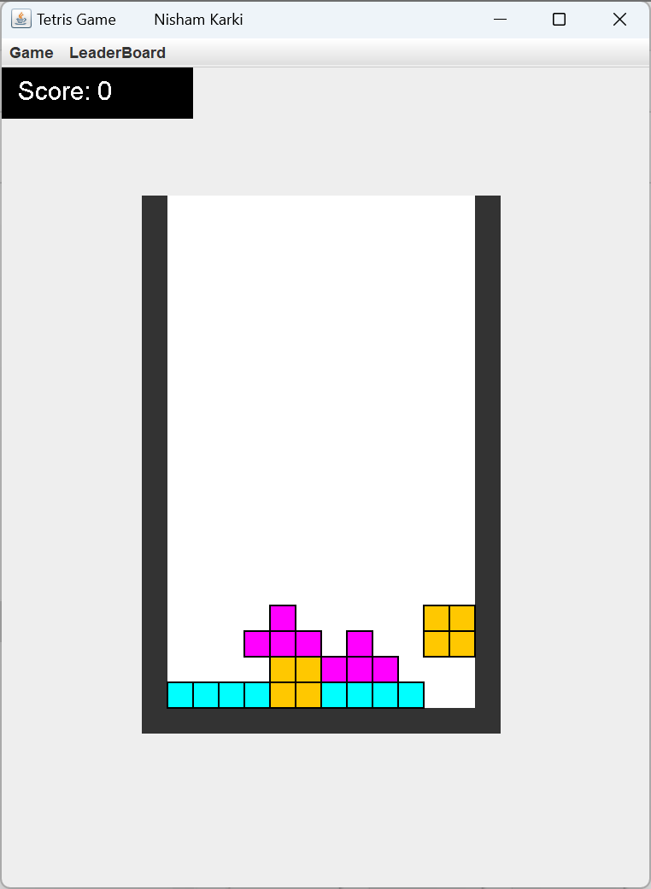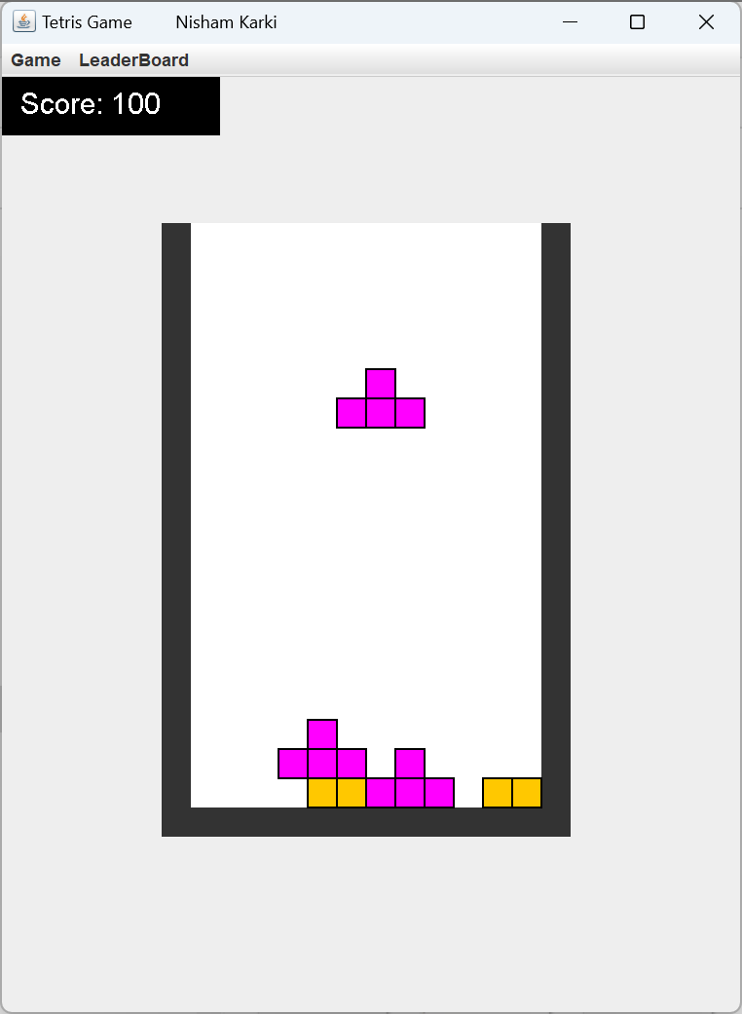

- Please, take a screen shot of a position before and after two rows have disappeared.
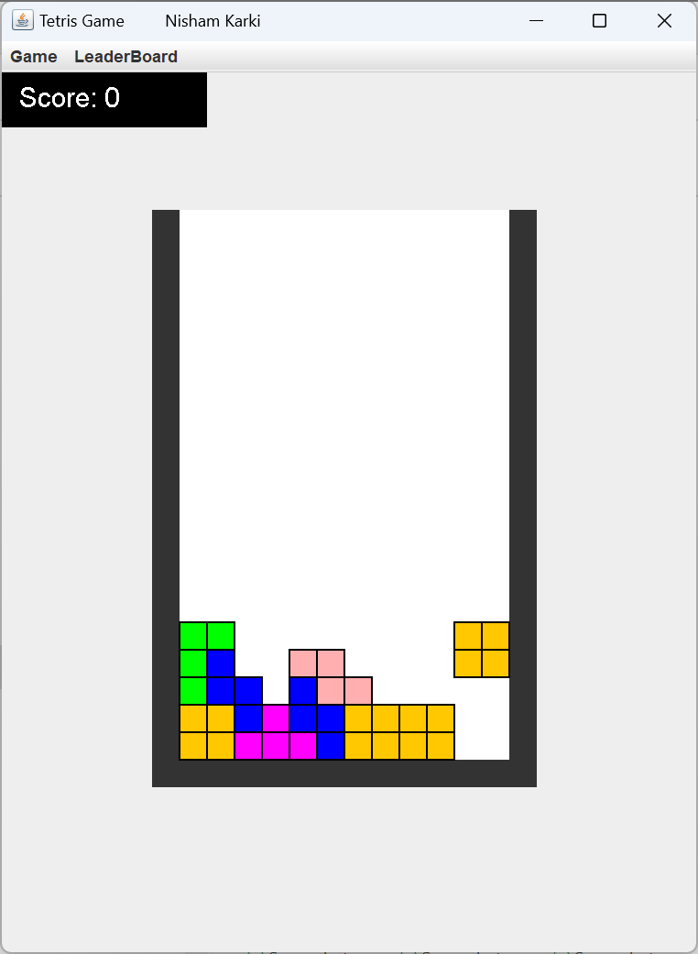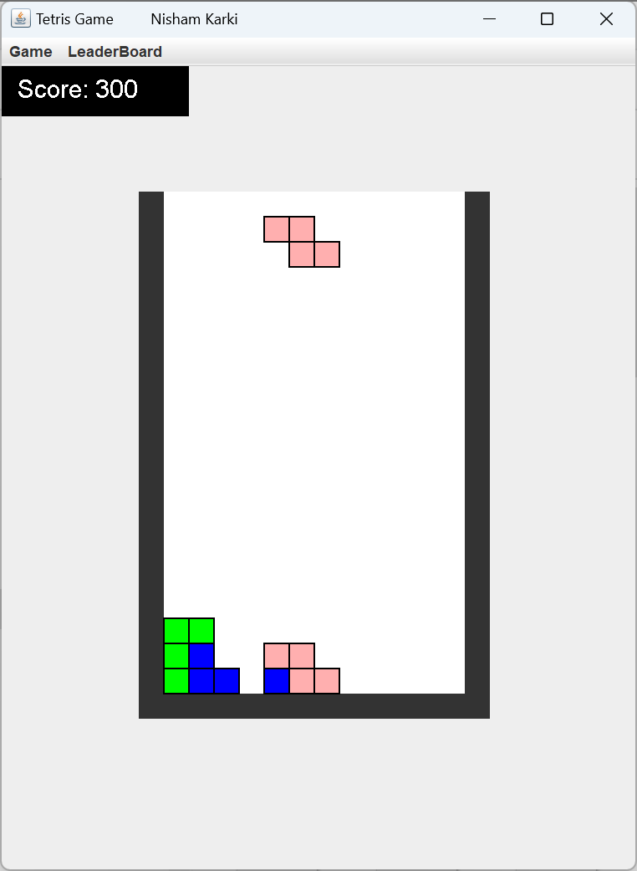

- Please, take a screen shot of a position before and after three rows have disappeared.
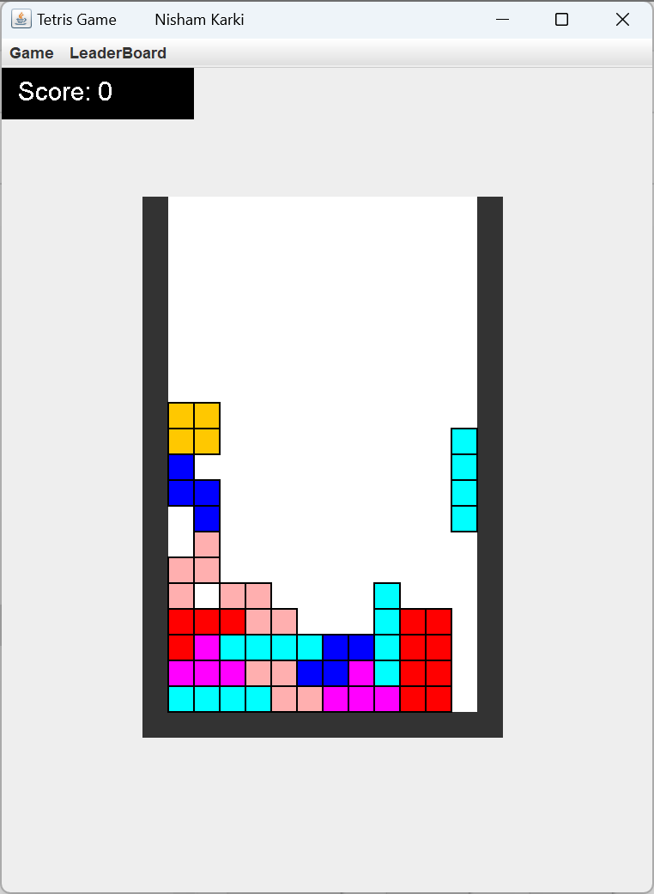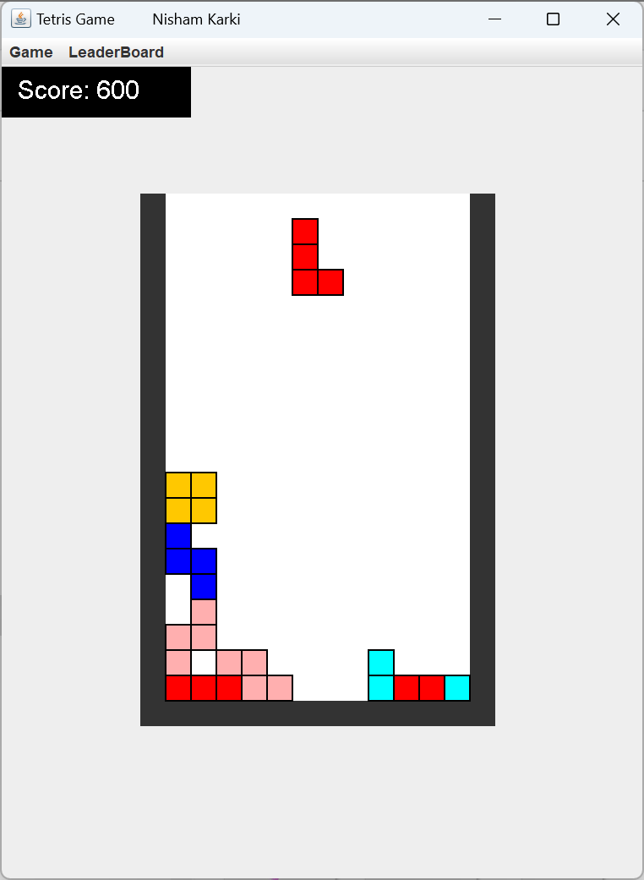

- Please, take a screen shot of a position before and after four rows have disappeared.

